A Project Report

On

**Restaurants Booking Website**

Developed At

**Harivandana College**

For the fulfillment of the requirements for the

**B.C.A. – 5th Semester[2023]**

**Developed By**

Dharmesh J. Ramoliya

Submitted To



**DEPARTMENT OF COMPUTER SCIENCE**

**-: Under the Guidance of :-**

**Dr. Ashwin Rathod (Head of Department)**

**Dr. Dharmendra Ambani (Project In-charge)**

**Prof. Bhavesh Chavda (Project In-charge)**

**Acknowledgement**

* At first, I praise to “Harivandana College” Who give me Opportunity, Capability and Energy to Complete this Project Work.
* Provide us a lot of support & guidance from the Start to End of the project development.
* We are very Thankful to the project coordinator of Prof. Dharmendra Ambani, Prof. Bhavesh Chavda of Harivandana College.
* I would like to thanks to all of our Friends and those who helped, inspired and gave us mental support at different stages in different moment in my Project.
* Again also thanks to the Almighty for helping in Successfully ending this Project work.

**Abstract**

* The Website is user friendly simple, fast and cost – effective, forpersonal use and makes the data processing very fast.
* Having a website is very crucial for a business. Websites have paved the way for businesses to carry out their operations as long as they are having internet access.
* Today websites are not only owned by businesses, even individuals who are interested in a particular niche can write articles related to that.
* The basic concept of the web application is to allow the customer to shop virtually using the Internet and allow customers to buy the items and article of their desire from the store.

**Summary**

* With the completion of this chapter, I have taken my first step in my journey to build these websites. This chapter was a great first step, covering many important aspects of websites, web pages, and web page authoring tools.
* This chapter began by looking at the three things all websites have:
* A web server to return the requested web pages to the requesting web browsers
* A domain name to uniquely identify the website
* Web pages, which make up the building blocks of a website
* A web server is a computer where a website's web pages reside. It is this web server that is queried when a user visits the website through a web browser. The domain name is a unique identifier for a website. To visit the home page for a particular website, simply enter the domain name in your web browser's Address bar. Finally, a website is composed of one to many web pages. Each web page is, in actuality, a file residing on the web server. Web pages contain HTML markup that specifies how their content should be displayed in a web browser.

**Index**

|  |  |  |
| --- | --- | --- |
| **NO** | **Subject Title** | **Page**  **No.** |
| **1** | **Introduction**   * Scope of Object * Purpose * Literature Review | **8** |
| **2** | **Literature Review**   * Technology Used * Feature of MySQLi * Connectivity * Localization * Client and Tools * Why to Use MySQLi * phpMyAdmin * Hardware Requirement * Software Requirement | **9** |
| **3** | **System Analysis**   * Study of Current System * Requirement of new System * Overview of proposed System | **15** |
| **4** | **Project Management**   * Project Planning and scheduling * Phases * Project Planning * Risk Management * Risk Identification | **19** |
| **5** | **User Case**   * Administrator Function | **23** |
| **6** | **Data Dictionary**   * Admin * cetaloge * Customer * Contact us | **27** |
| **7** | **Use case Diagram**   * Use case Diagram of Users * Use case Diagram of admin   **Data Flow Diagram**  **➔ Both Side**   * User Case * Client Side User Case * Admin Side User Case   **DFD Diagram**   * DFD 0 Level * DFD Level 1 Client Side * DFD Level 1 Admin Side | **35** |
| **8** | **CFD (Control Flow Diagram)**   * CFD from Admin Side * CFD from User Side | **39** |
| **9** | **Implementation Planning and Detais** | **40** |
| **10** | **Testing**   * Black Box Testing * White Box Testing | **41** |
| **11** | **Frontend Screenshot** | **44** |
| **12** | **Admin Screenshot** | **52** |
| **13** | **Limitation and Future Enhancement** | **60** |

1. **Introduction**

* The Project Hydraulic Jack Manufacturer has been developed on HTML, PHP, CSS, JavaScript, Bootstrap5 and MySQLi.
* I have done frontend design (website design and development in frontend design) and backend design (admin panel design and development in backend design) to make a dynamic website.
* Being a dynamic website, a **MySQLi** database is used to connect the frontend design and the backend design.
* There are two types of Users available in the Project

1. Admin
2. Customer

* Customers or Users have limited access right to access the System while the Admin Users have Full Control over the System.
* I have Used **PHP** for business logic.
* **MySQLi** as a Database.
* **HTML** is used for designing the structure.
* **CSS** is used for web page formatting.
* **JavaScript** is used for form validation and animation.

**Scope of Project**

* By using our website customer can know about hydraulic jack.
* The products, sub-products and categories we provide are listed in our website.
* There is an option to download PDF files in the category from the website. The customer who downloaded the PDF files filled the form By sending, mail will be received in the email id and PDF files will be downloaded.
* With the help of the website, some people will get their hydraulic jack need fulfilled.

**Purpose**

* The main purpose is that you can easily buy a hydraulic jack.
* The website is mainly used for online hydraulic jack information and purchase.
* You can get product much more affordable price from our.
* You can get different types of products from us at more affordable prices.

1. **Literature Serve**

**2.1) Technology Used**

**Overview of the technology :**

**Font-End:-** HTML, CSS, JavaScript, Bootstrap

**HTML:-** HTML is use to Create and Save Web Document.

E.g. Notepad/Notepad++, Visual Studio Code.

HTML Stands for “**Hypertext Markup Language**”. It can be assisted by technologies Such as Cascading Style Sheet (CSS) and Scripting language such as JavaScript.

This language is used to annotate (make notes for the computer) text so that a machine can understand it and manipulate text accordingly. Most markup languages (e.g. HTML) are human-readable. The language uses tags to define what manipulation has to be done on the text.

**CSS:-** (Cascading Style Sheets) Create attractive Layout. Using **CSS**, you can control of the text, the Style of Fonts, the Spacing between Paragraphs, how Columns are sized and laid out, what Background Images or colors are **used**, layout designs, Variations in display for different devices and Screen sizes as well as variety of other Effects.

**JavaScript:-** It is a Programming Language, commonly use with Web browsers. **JavaScript** is a dynamic Computer Programming Language. It is lightweight and most commonly used as part of web pages, whose implementations allow client-side Script to interact with the user and make dynamic Pages. It is an Interpreted Programming Language with object-oriented capabilities.

**Bootstrap:-** Bootstrap is a free and open-source tool collection for creating responsive websites and web applications. It is the most popular HTML, CSS, and JavaScript framework for developing responsive, mobile-first websites. It solves many problems which we had once, one of which is the cross-browser compatibility issue. Nowadays, the websites are perfect for all the browsers (IE, Firefox, and Chrome) and for all sizes of screens (Desktop, Tablets, Phablets, and Phones). All thanks to Bootstrap developers -Mark Otto and Jacob Thornton of Twitter, though it was later declared to be an open-source project. Bootstrap has evolved many versions and every time when we want to use this framework we can select the version which we want to use.

**Back-End:-** PHP, MySQLi .

**PHP:-** Hypertext Pre-processor (PHP) is a technology that allows Software developers to create dynamically generated web page, In HTML, XML or other document type, as per Client request. PHP is Open Source Software.

PHP is a webscripting language, this language is used for develope it project. Many file are create in php file and use with CSS and complete a design of home page and other page. PHP in a many class and session are create and use for some output.

However, PHP is the best known for its database interfacing capabilities. With PHP you can establish a database connection to any of standard database servers. Update the content of a data-base, even manipulate a particular database schema. The results of queries are easily converted into a valid HTML that is sentback to the client.

**MySQLi Server:-**

MySQLi is an Open Source, SQL Relational Database Management System (RDBMS) that is Free for many uses.

The **MySQLi Extension** (MySQL improved) is a relation data-base Driver used in the PHP Scripting Language to Provide an interface with MySQL databases. There are three main API options when considering Connecting to a MySQL data-base Server: PHP’s MySQL Extension. PHP Data Object (PDO).

The data in MySQLi is stored in tables. A table is a Collection of related data, and it consists of columns and rows, Data-bases are useful when storing information categorically.

There is for instance, a function library for Manipulating MySQLi Database, Informix Database and much more. There are Several different Steps that execute Scripts:

The Script Uses the MYSQLI_CONNECT() function in order to establish a connection to MySQLi Server. The MYSQLI_CONNECT() function takes three values as its arguments.

**Hostname:-** The name of the host to which to establish the connection. In our case it is the “localhost” because bothServers. The Web Server and the MySQLi Server are running on the same machine.

**Username:-** The name of a user that has privileges to Manipulate the Test Database that we Created. Default is “root”.

**Password:-** The Valid Password of the User.

**2.2) Feature of MySQLi**

**Internals and portability:-**

* Written in C and C++.
* Tested with a board range of different compilers.
* Works on many different platform.
* Uses multi-layered server design with independent modules.
* Security
* A privilege and Password System that is very flexible and secure, and that enables host-based Verification.
* Password Security by encryption of all Password traffic when
* you connect to a server.

**2.3) Connectivity**

**Clients can connect to MySQLi Server using Several Protocols:-**

* Client can connect using TCP/IP sockets on any platform.
* On Windows Systems in the NT family (NT, 2000, XP, 2003, or Vista), Client can connect using named pipes if the server is started with the enable-named-pipe option. In MySQL 4.1 and higher, Windows servers also support Shared-Memory connections if started with the shared-memory option. Client can connect through shared memory by using the protocol memory option.

**2.4) Localization**

The Server can Provide error message to Clients in many Language.

**2.5) Client and Tools**

* MySQLi includes several Client and utility Programs. These include both command-line Programs such as mysqldump and mysqladmin, and graphical Programs such as MySQL Workbench.
* MySQLi server has built-in support for SQL statements to check, optimize, and repair tables. These statements are available from the command line through the mysqlcheck Client.
* MySQLi Programs can be invoked with the help of Option to obtain online assistance.

**2.6) Why To Use MySQLi**

* Leading Open Source RDBMS.
* Ease of use – No frills.
* Fast
* Robust
* Security
* Multiple OS support
* Free
* Technical Support
* Support Large Database -up to 50 Million rows, file size limit up to 8 Million TB.

**2.7) phpMyAdmin**

* phpMyAdmin is a Free software tool written in PHP, intended to handle the administration of MySQLi over the Web. phpMyAdmin supports a wide range of operations on MySQLi and MariaDB.
* Frequently used operations (managing, databases, tables, columns, relations, indexes, users, permissions, etc) can be performed via the user interface, while you still have the ability to directly execute any SQL statement.
* By that time, phpMyAdmin had already become one of the most popular PHP applications and MySQL administration tools, with a large community of users and contributors.

**2.8) Hardware Requirements**

* **Processor:** Pentium 3.0 GHz or higher
* **RAM:** 1024 MB or more
* **Hard Drive:** 10GB or more
* **Minimum OS:** Windows XP, Vista, 7, 8 Browser Software.
* Internet Services or Local host Server.

**2.9) Software Requirement**

* Windows XP/7/8/10.
* XAMPP or WAMPP
* Notepad++ / Visual Studio Code

1. **System Analysis**

It is a process of collecting and interpreting facts, identifying the problems, and decomposition of a system into its components.

System analysis is conducted for the purpose of studying a system or its parts in order to identify its objectives. It is a problem solving technique that improves the system and ensures that all the components of the system work efficiently to accomplish their purpose.

**Objective:**

The main objective of this system is to reach maximum customers At the right time to increase business sales and profitability. This will enable data integrity across the breadth of the system. So an online order management system will provide such a facility Providing any hydraulic jack so that he can easily order hydraulic jack At their doorsteps and it is also very useful for customers as it saves their time and money.

* To shopping via Internet and Online.
* Customer has no need to gone for a shopping in outside the home.
* It is Save the time of the customer.
* The main objective of the project is to create a system that allows users to order the hydraulic jack.
* Selected hydraulic jacks are displayed in tabular format and can be purchased by calling us and buyers of hydraulic jacks.
* User can order their hydraulic jack through credit/debit card payment.

**3.1) Overview of proposed System:**

We are also manufacture this all Product and User can get all information in about order in delivery parcel.

**3.2) Hardware:**

If there is a website project for a vegetable shop Operating system like compatible on every browser windows 7 and higher versions will support it.

**3.3) Software:**

* **Font End Tools:** PHP
* **Back End Tools:** MySQLi
* **Feasibility Study:**

A feasibility study is carried out to select the best system that meets performance requirements. A feasibility study is designed to provide an over view of the primary issues related to a business idea. Three tests of feasibility-all equally important are studied: Operational, Technical and Financial.

* **Operational Feasibility:**

The proposed System will meet the operational Requirements like System Performance, accessibility of information, client acceptance and efficient solutions to the queries of the user.

If user has some basic knowledge of Internet, User can operate this Website easily. It provides easy user Interface.

Operational feasibility has been considered form the user’s point of View. This Website once deployed. It can run easily without any maintenance at this point to time. After the inclusion of Database in future, the Database might need some clean up after some period of time. If the database size becomes large, then it might need some changes in handling of the Website and require some Optimization so that Website runs Faster and retrieves data faster.

* **Behavioural Feasibility:**

Proposed System will behave according to the requirement made or not. Responses time of the System must be noticed because it is a web based System whether it takes too much time to response or give quick response or response in the specific period of time this consideration is most important. Time consuming Processes are possible to run on this environment or not it is also important.

* **Technical Feasibility:**

This System can be easily Supported by the Hardware and Software requirements of any System.

For End user they just require Username and Password facility to manage their Project. And we are developing Website using most recent Apache web server (XAMPP), which uses MySQLi Developer as Database. It is capable to Store data and provide concurrent access to Information and Adequate responses accurately. Also we will try our system to make it as Expandable as Possible. We also provide Reliability, ease of access, and data Security because this is not a Final Project.

* **Economic Feasibility:**

The Hardware requirement of the System is at least a PC for an Administrator to handle the site from Admin panel. The development cost of the Projects is not much higher.

The cost required for the Creation of our System will be less Compared to the benefits provided by our System.

This System is User friendly so anyone who have a basic knowledge of Computer and then he/she can use easily. And it is also low cost because no need to attach extra Hardware.

**4. Project Management**

Project Management is an important part of project development. It deals with all the main areas of the project development like Feasibility, Requirement analysis, Project Schedule, Project plan etc. We have used the Project Management approach to deal with all these areas. It is achieved by proper selection of Software Life Cycle Model.

**4.1) Project Planning and Scheduling:**

Project planning is perhaps one of the most important works in developing works in developing any project. Before the project can begin estimate regarding work to be done, what recourse’s will be required and how much time will elapse from start to the finish of project. Planning helped us to prepare a framework that enabled to make us a reasonable estimate of all such things.

**4.2) Phases:**

Incremental development slices the System functionality into increments (portions). In each increment, a slice of functionality is delivered through cross-discipline work, from the requirements to the deployment. The unified process groups increments/iterations into phases:

* **Inception:** Inception identifies Project scope, Requirements (functional and non-functional) and risks at a high level but in enough detail that work can be estimated.
* **Elaboration:** Elaboration delivers a working architecture that mitigates the top risks and full fills the non-functional requirements.
* **Construction:** Construction incrementally fills-in the architecture with production-ready code produced from analysis, design, implementation, and testing of the functional requirements.
* **Transition:** Transition delivers the System into the Production Operating environment.

**4.3) Project Planning:**

Project planning is a discipline addressing how to complete a project in a certain timeframe, usually with defined stages and designated resources.

One view of project planning divides the activity into these steps: setting measurable objectives.

A plan is drawn up at the start of the project, should be used as the driver of the Project. The Project Planning consists of:

* Selection of suitable Software Development process model which I have Selected Interactive Waterfall Model.

**4.4) Risk Management:**

Risk management is the continuing process to identify, analyze, evaluate, and treat loss exposures and monitor risk control and financial resources to mitigate the adverse effects of loss.

Loss may result from the following: financial risks such as cost of claims and liability judgments.

Risk Management is the process of measuring, or assessing, risk and developing strategies to manage it. Strategies include Transferring the Risk to another party avoiding the Risk, reducing the Negative Effect of the Risk.

**4.5) Risk Identification:**

Risk identification is the process of documenting any risks that could keep an organization or program from reaching its objective. It's the first step in the risk management process, which is designed to help companies understand and plan for potential risks. Examples of risks include theft, business downturns, accidents, lawsuits or data breaches.

After Establishing the Context, the next step in the process of managing Risk is to Identity potential Risks are about events that, when Triggered, cause Problems. Hence, Risk Identification can Start with the source of Problems, or with the Problem itself.

1. **Use Case Diagram**

* Use-case diagrams model the behavior of a system.
* Used to illustrate the functional requirements of the system and its interaction with external agents(actors).
* A use case diagram gives us a high level view of the system without going into implementation details.

**5.1) Use Case Diagram of Users**

**Call Now**

**Book table**

**5.2) Client side use case daigram **

**DataBase**



**5.3) Admin Side Use case Daigram**

**DataBase**

**General Setting**

**Login**

**Series**

**Testimonial**

**Product**

**Certificates**

**Feature Images**

**Sub-Product**

**Description :**

* When the user visits the website while downloading the PDF in product, sub-product and category by first filling the contact and sending the mail is sent and the PDF is downloaded.

**Administrator Function :**

* Image is automatically deleted when deleting product, subproduct and category from admin panel image.
* Product, subproduct and category can be edited from the admin panel image.
* Products, subproducts and categories can be added from the admin panel image.
* PDF can be added while adding to the category field in the admin panel.

**6. Data Dictionary**

**RESTAURANTS BOOKIN GDATABASE TABLES**

**Admin**

|  |  |  |
| --- | --- | --- |
| **No** | **Table Name** | **Table Use** |
| 1 | Admin | Admin Manage |
| 2 | Category | Category Manage |
| 3 | Sub-Category | Sub-Category Manage |
| 4 | Table Book | Table Book manage |

**Category**

|  |  |  |
| --- | --- | --- |
| **id** | **Category name** | **image** |
| int | Varchar(151) | Varchar(151) |

**Sub-category**

|  |  |
| --- | --- |
| **Id** | Int(5) |
| **category** | Int(5) |
| **Sub-category** | Varchar(151) |
| **image** | Varchar(200) |
| **price** | Int(5) |
| **description** | Varchar(200) |

**Table Book**

|  |  |
| --- | --- |
| **Id** | Int(3) |
| **Name** | Varchar(50) |
| **Email** | Varchar(50) |
| **Contact** | Bigint(12) |
| **Person** | Int(2) |
| **Date** | date |

**Client Site**

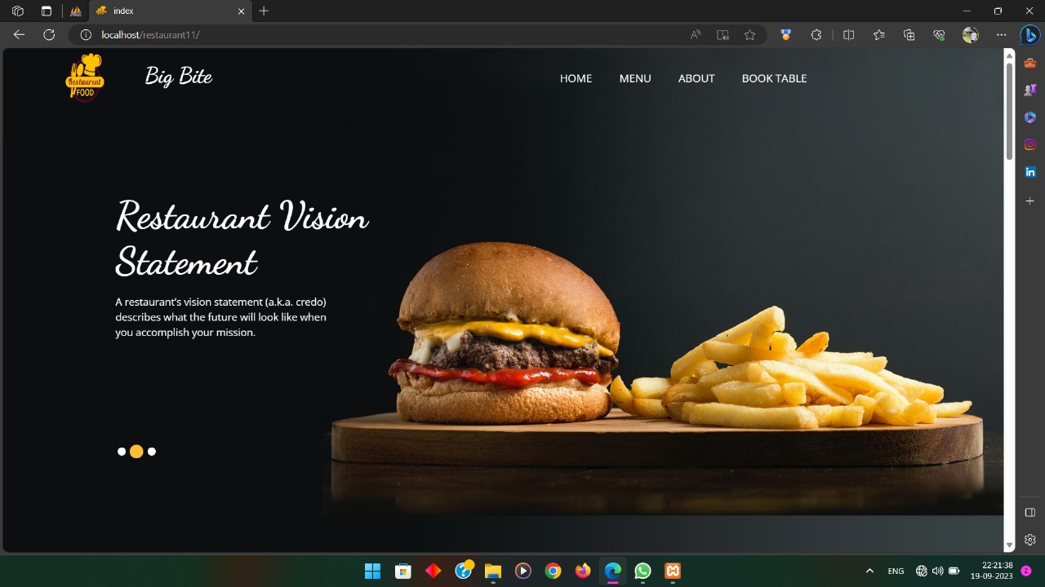

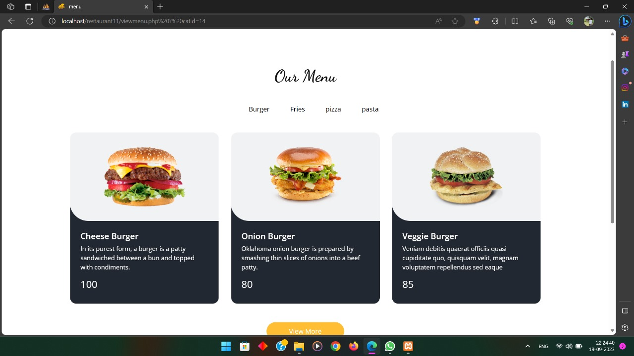

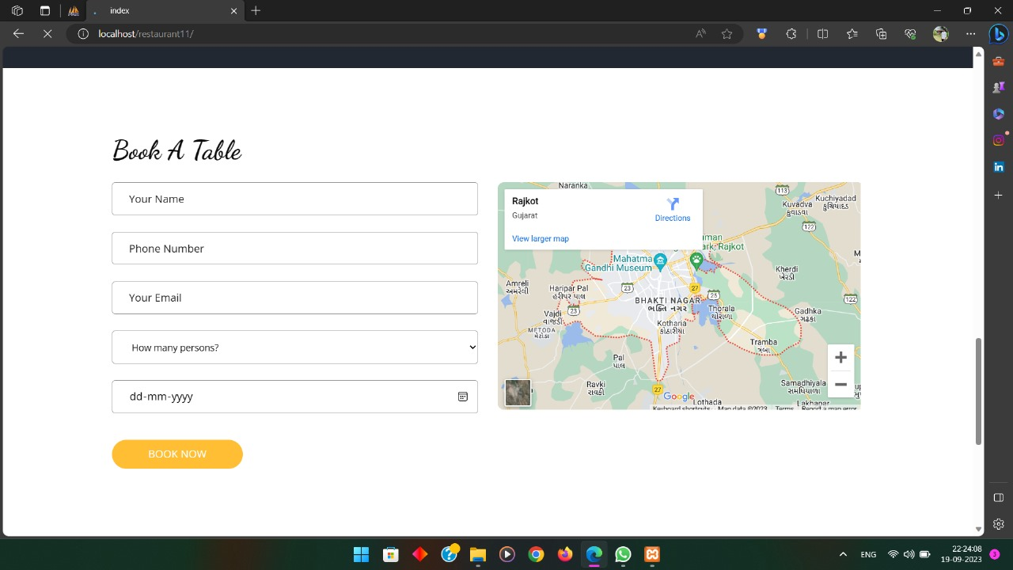

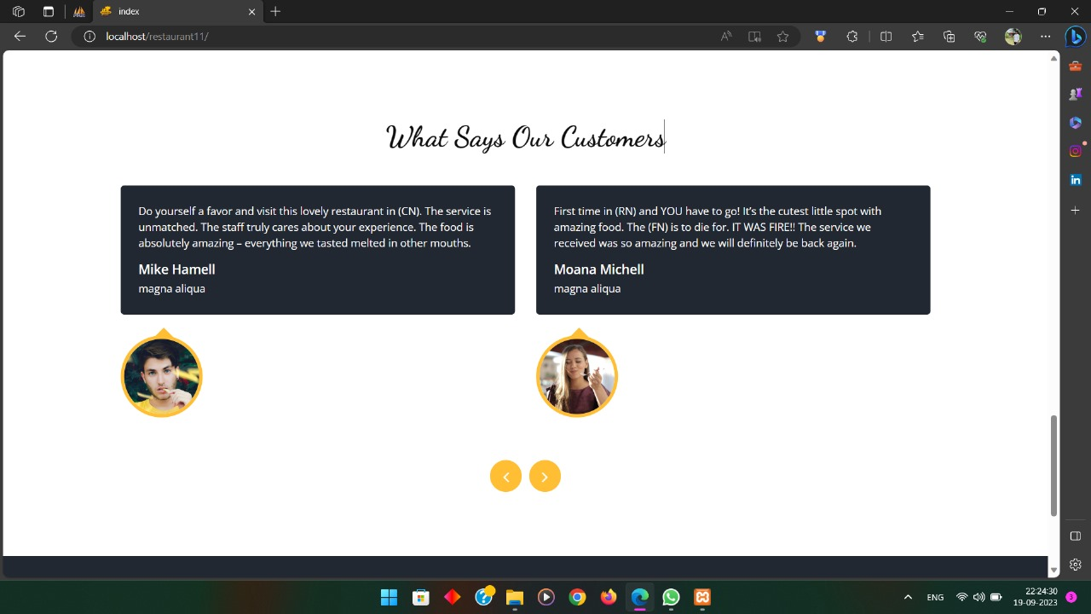

**7. Data Flow Diagram**

* **Data Flow Diagram from boh Side**

**PDF Download**

**Series**

**Subproduct**

About us

product

**Contact us**

**Restaurants**



**client**

**Admin**

**Home**

**Login**

**product**

**subproduct**

**series**

**sector**

**General setting**

**Testimonial**

**All slider image**

**Change Login**

* **DFD Diagram (Data flow Diagram)**

**Login**

**Hydraulic Jack Manufacture**

**Show Hydraulic Jack**

**Manage admin panel**

* **DFD Level 1 (Diagram)**

**Client Side:**

**Verify By Login Table**

**Process To Store Data**

**Login**

**Registration**

**Registration**

**Project Database**

**Login**

**Logout**

**View product**

**sectors**

**Project Database**

**Database**

**Valid**

* + **DFD 1 Level Diagram**
* **Admin Side**

**Login**

**Edit**

**Home**

**Add Slider**

**View sector**

**View subproduct**

**View product**

**Add sectors**

**Add subproduct**

**Add product**

**Testimonial**

1. **control flow diagram**

* **CFD from Admin Side**

**Admin**

**No**

**Login**

**Login**

**Page**

**Home**

**Administrator**

* **CFD from Client Side**

**All user**

**Call Now**

**Contact us**

**View website**

**9. Implementation Planning and Details**

**Implementation Environment :**

* This application is made by keeping in mind the basic Con-cept of Website Development, the Website can be used by each of the Person at a time on their respective Systems.
* This Website is also made in such a way as to provide user with the most Effective Graphical Interface. So that the user can easily search out for Hydraulic Jack Manufacture and Navigate through out the Website with the ease of using this Website.
* So, As the conclusion of above two points, this Website is having the multi-user and Effective GUI environment for the users.

**10. Testing**

* This includes the methods that were used for testing, Validating, and evaluating the System. The Conclusion and the Future Work for the Software are also given.
* Start with a base Function that you want to implement.
* Create a document with the detailed requirement definition, activity diagram with a description of the Flow, Database tables to be used, a Component diagram, and a Description of each component with the precondition and tables that would be affected by the component.
* Give the document to the tester, and work with the tester while he or she writes the code to check if the steps in the document can be implemented and if the result of each use case can be achieved.
* Ask the tester to log on all the errors and difficulties he or she en countered while working on the prototype implementation.
* When the testing approach was implemented, the following pros and cons regarding the testing approach were realized.
* Pros of using the methodology
* Helps give a better understanding about the requirements.
* Better design at the end of the cycle.
* Reduced testing to be performed at the end of the cycle.
* Documents produced would be of higher quality.
* Cons of using the methodology
* The person working on the document should be experienced.
* There are increased time and money involved with testing.
* Different view points for the same problem can lead to varying results.
* **Testing Method:**

There are mainly Strategies are there.

* Black Box Testing
* White Box Testing

**Black Box Testing:**

Black Box Testing is testing without knowledge of the internal workings of the Item being tested. For example, when black box testing is applied to Software Engineering, the tester would only know the legal Inputs and what the expected Outputs should be, but not how the Program actually arrives at those outputs.

It is because of this that black box testing can be considered testing with respect the specifications, on other knowledge of the program is necessary.

For this reason, the tester and the programmer can be in-dependent of one another, avoiding programmer bias toward his own work. For this Testing, test groups are often used.

Also, due to the nature of black box testing, the test planning can begin as soon as the specifications are written.

**White Box Testing:**

White box testing strategy deals with the internal logic and structure of the code. White box testing is also called as glass, structural, open box or clears box testing.

The tests written based on the white box testing strategy in corporate coverage of the code written, branches, paths, statements and internal logic of the code etc.

In order to implement white box testing, the tester has to deal with the code and hence is needed to possess knowledge of coding and logic i.e. internal working of the code.

White box test also needs the tester to look into the code and find out which unit/statement/chunk of the code is mal- functioning.

The White Box Testing has also some advantages like as the Knowledge of internal coding structure is prerequisite. It becomes very easy to find out which type of input/data can help in testing the website effectively.

It helps in optimizing the code it helps in removing the extra lines of code, which can bring in hidden defects.

**Admin Site**

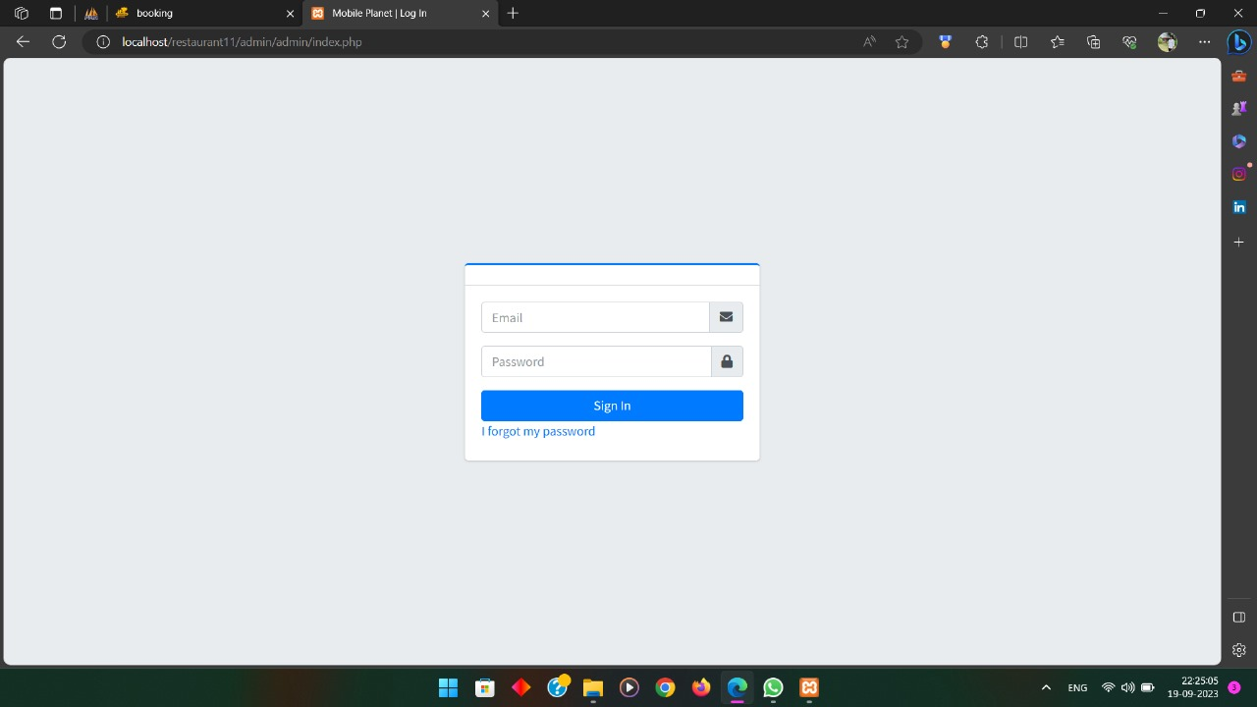

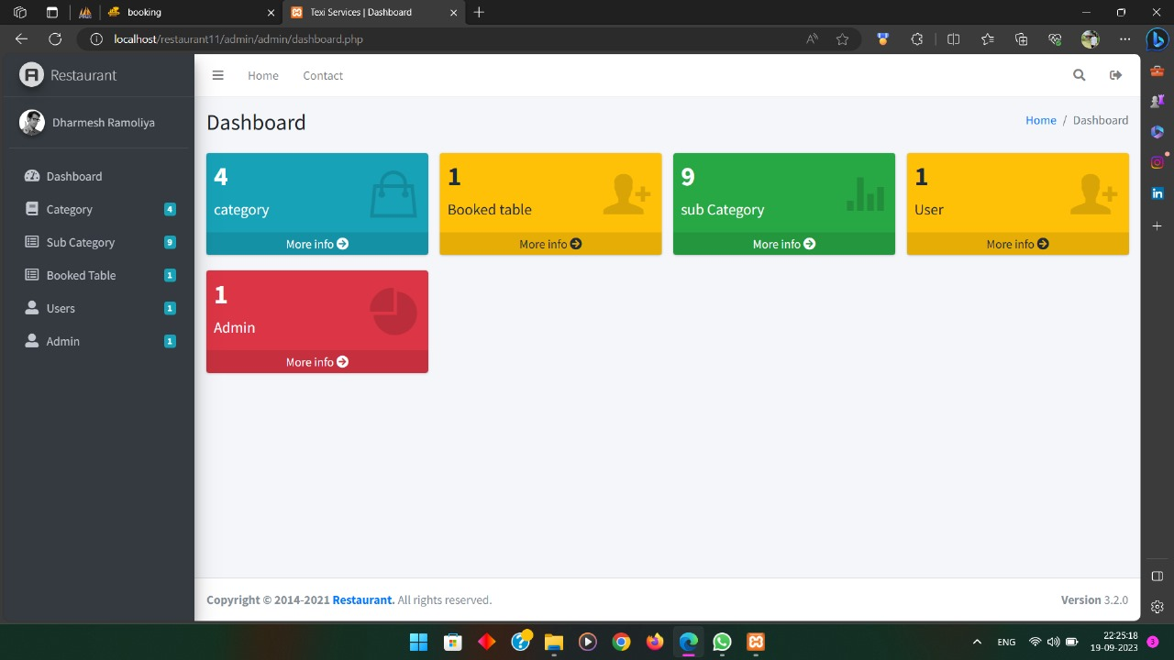

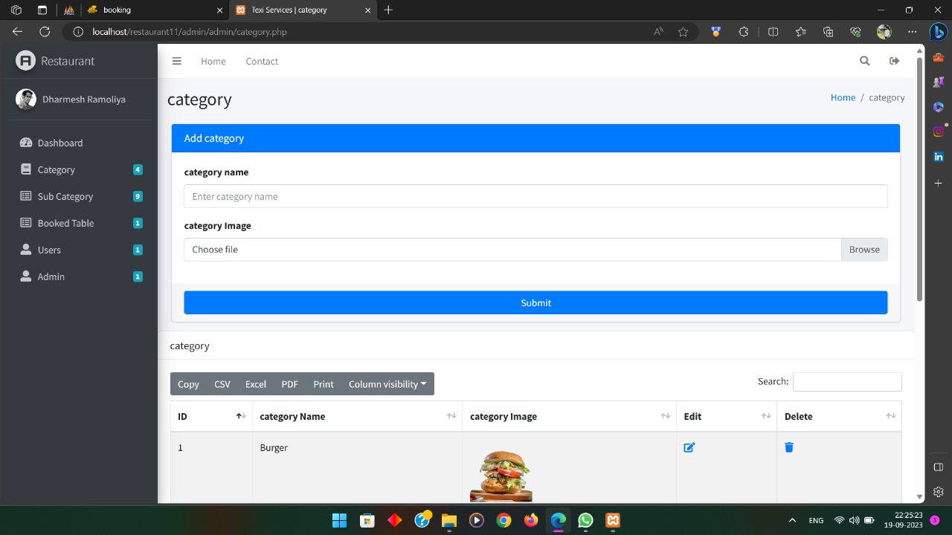

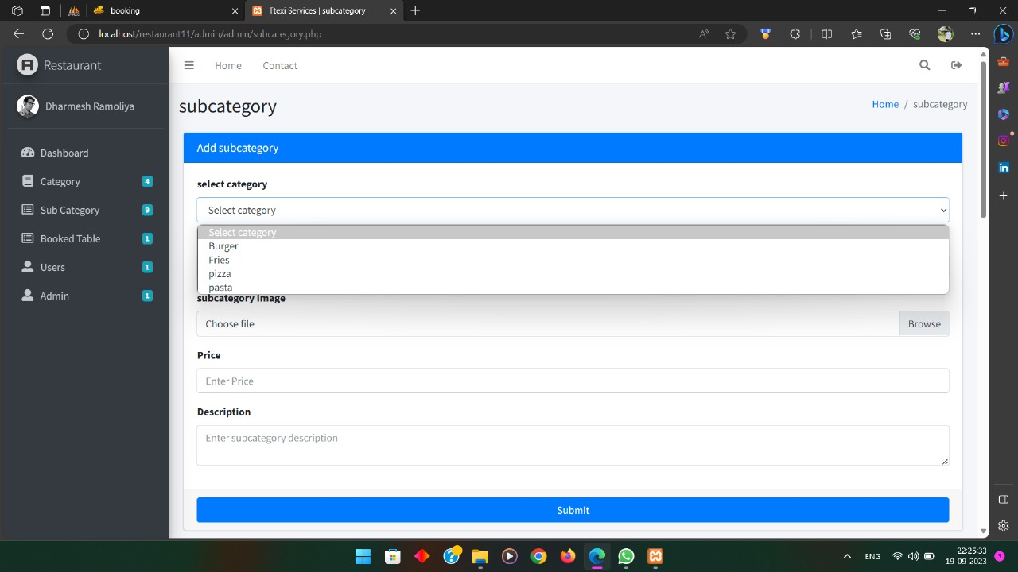

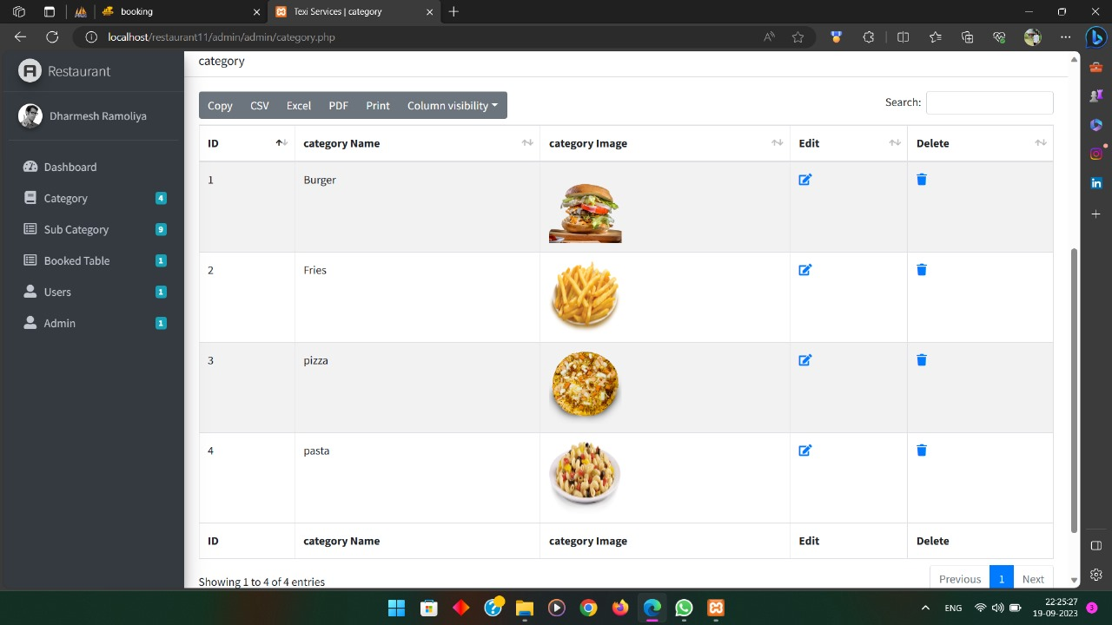

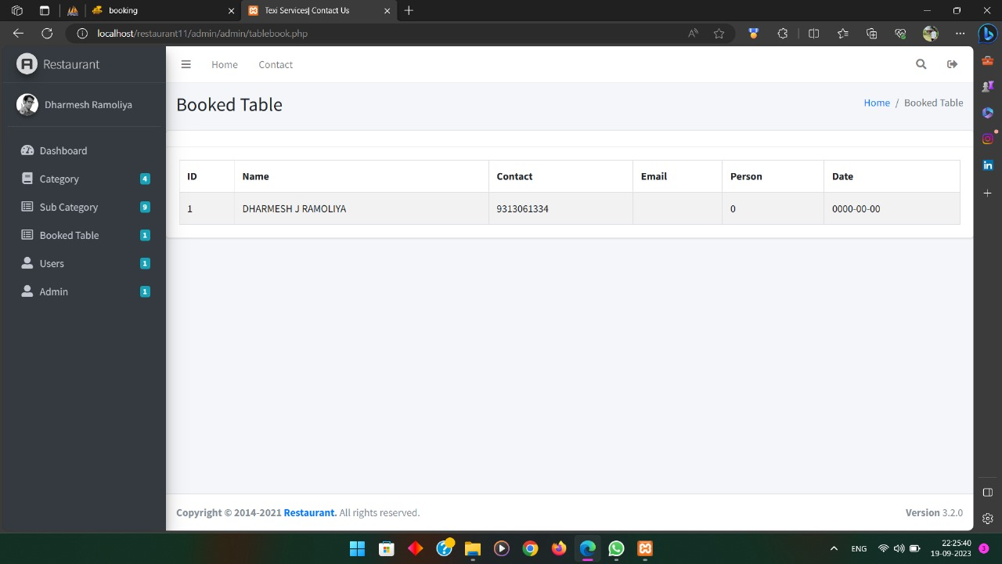

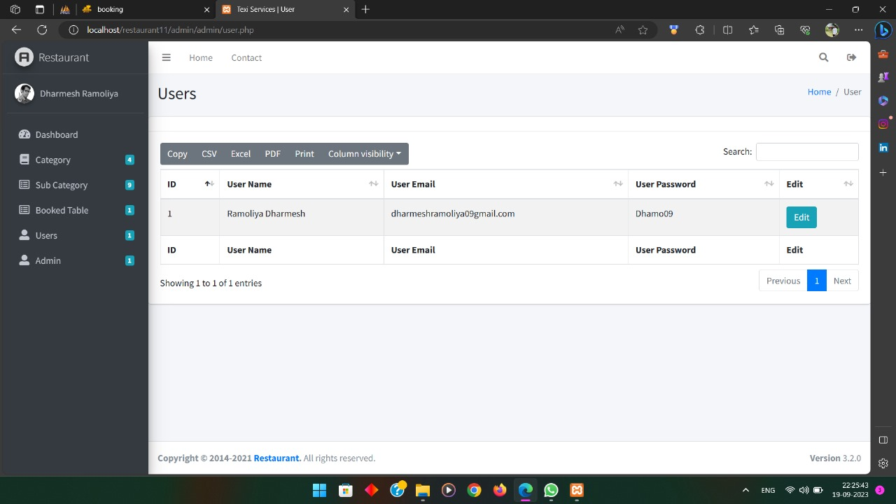

Thank you !

Developed by :- Dharmesh J. Ramoliya